**WEEK -1 : HANDS-ON EXERCISE**

**Design Principles and Design Patterns**

**Exercise 1: Implementing the Singleton Pattern**

**INPUT:**

**Logger.java:**

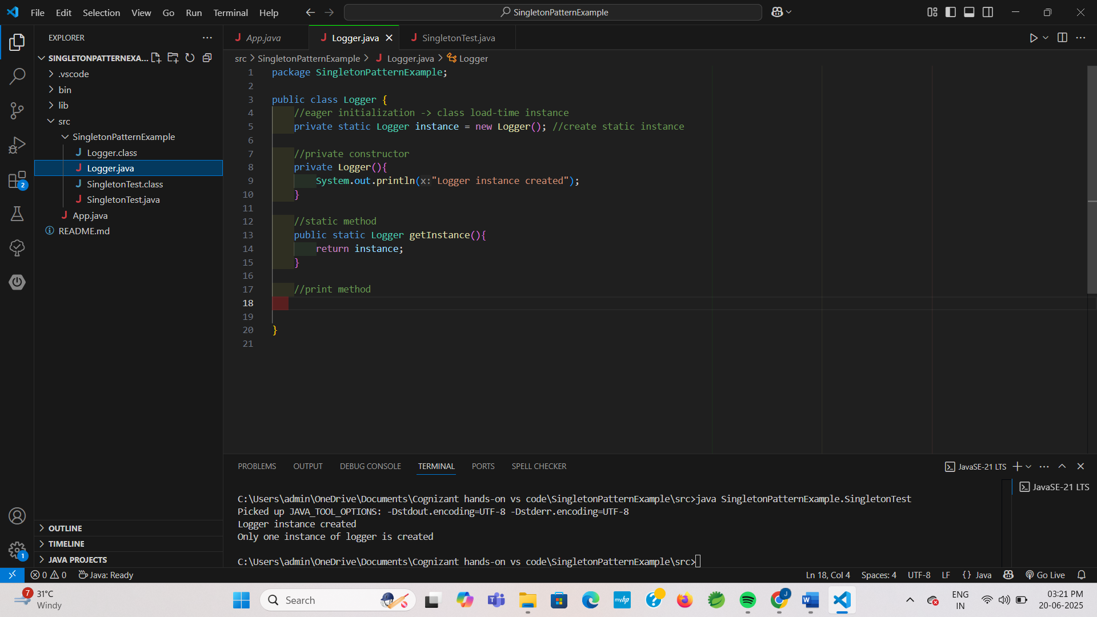

**SingletonTest.java:**

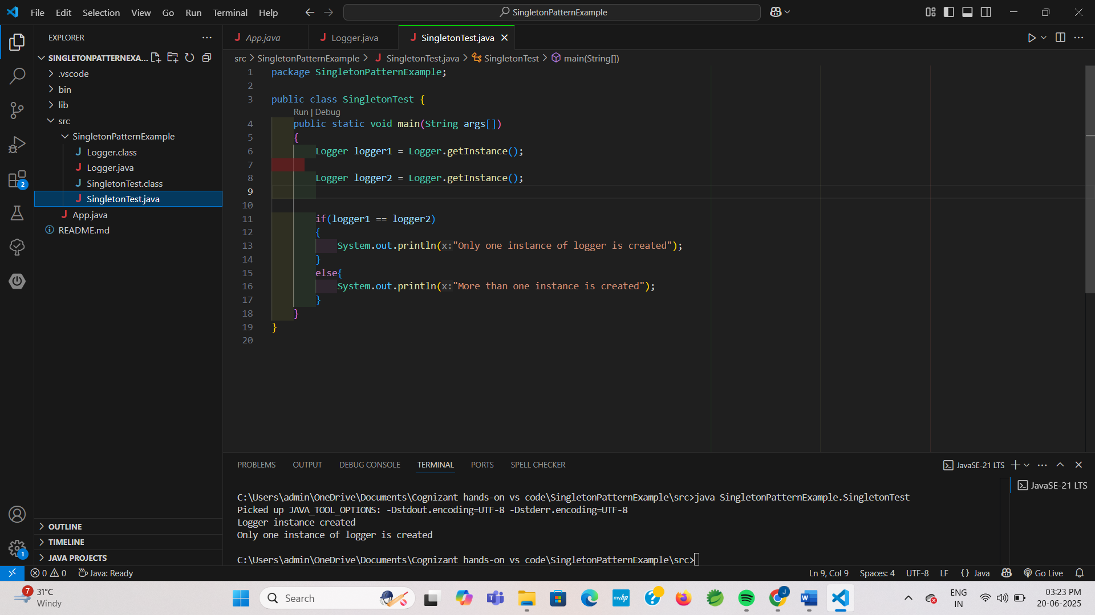

**OUTPUT:**

